- Install nginx and run nginx on port number 81.
Connect to ec2 instance
Install nginx using command – yum install nginx -y
Check the status of the service using command – systemctl status nginx
If its not active start the service – systemctl start nginx
Again check service status – systemctl status nginx
Change the directory to cd /etc/nginx
Enter vi nginx.conf and change the port number to 81 from 80.
Restart the service using systemctl restart nginx
lsof -i tcp:81
open browser and enter ip adders with port number 81
notice that the static nginx web page is loaded.

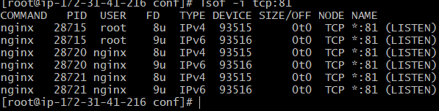

- Deploy a sample index.html file on nginx.
After deploying nginx
Change the directory to /usr/share/nginx/html
Vi index.html
Edit the text and save quit.
Launch the browser
Enter ip address with port number (currently on which nginx is running)
Notice the changes made to the web page

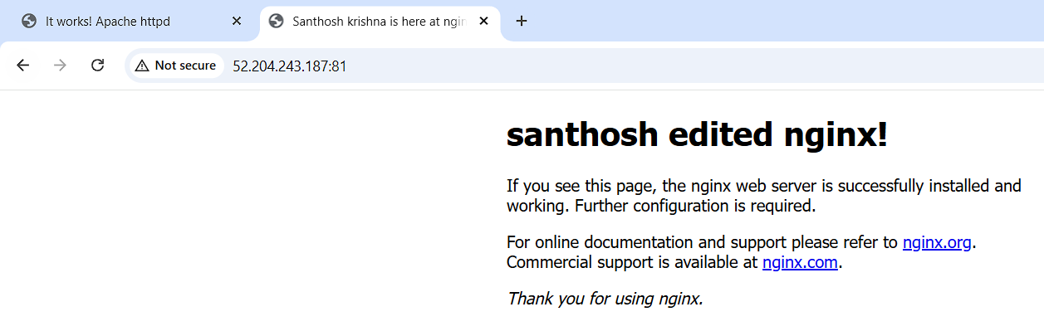
- Install Apache and run Apache on port number 82

Connect to ec2 instance
Install nginx using command – yum install httpd -y
Check the status of the service using command – systemctl status httpd
If its not active start the service – systemctl start httpd
Again check service status – systemctl status httpd
Change the directory to cd /etc/httpd/conf
Enter vi httpd.conf and change the port number to 82 from 80.
Restart the service using systemctl restart httpd
lsof -i tcp:82
open browser and enter ip adders with port number 82
notice that the static apache web page is loaded.

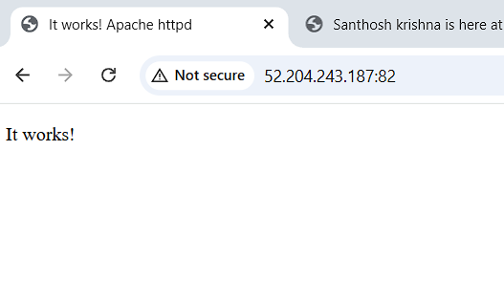

- Deploy a sample index.html file on Apache.

After deploying httpd
Change the directory to /var/www/html
Create index.html file Vi index.html
Edit the text and save quit.
Launch the browser
Enter ip address with port number (currently on which httpd is running)
Notice the changes made to the web page

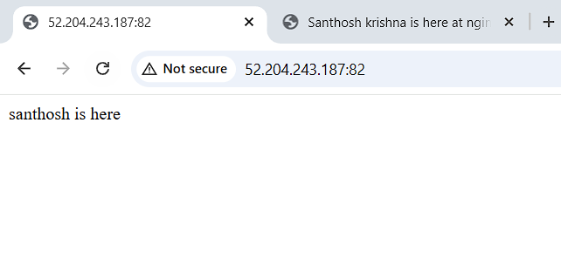

- Install Apache tomcat on port number 8082
Pre-requiste : install java “yum install java”
Wget “ tomcat tar file download web link”
Extract apache tar file
Change directory to extracted apache tomcat directory
Change to bin directory
To start apache tomcat service “bash startup.sh or ./startup.sh
On browser check enter ip address with port number 8080
Tomcat is installed page is displayed.

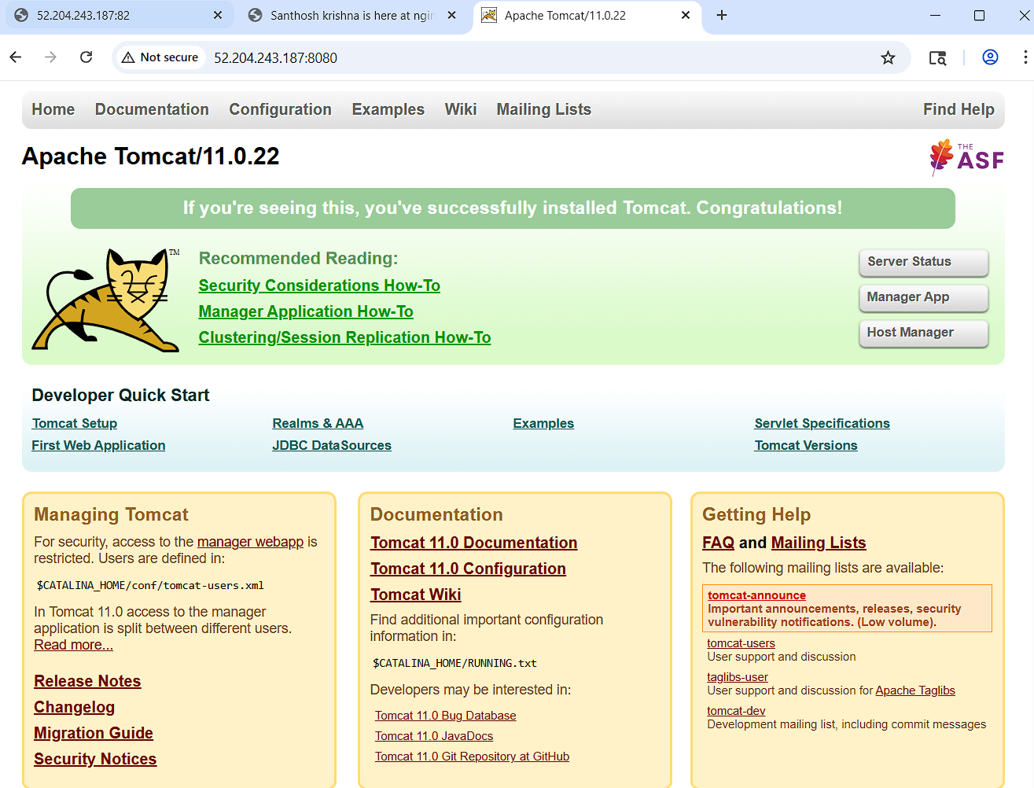

Extract and change directory to apache tomcat
CD to conf directory
Vi server.xml
Change port to 8082 from 8080
save file
cd bin and ./shutdown.sh as service is already running
again ./startup.sh the service
go to browser and enter ip address with 8082 port
see that the page is loaded sucessfully
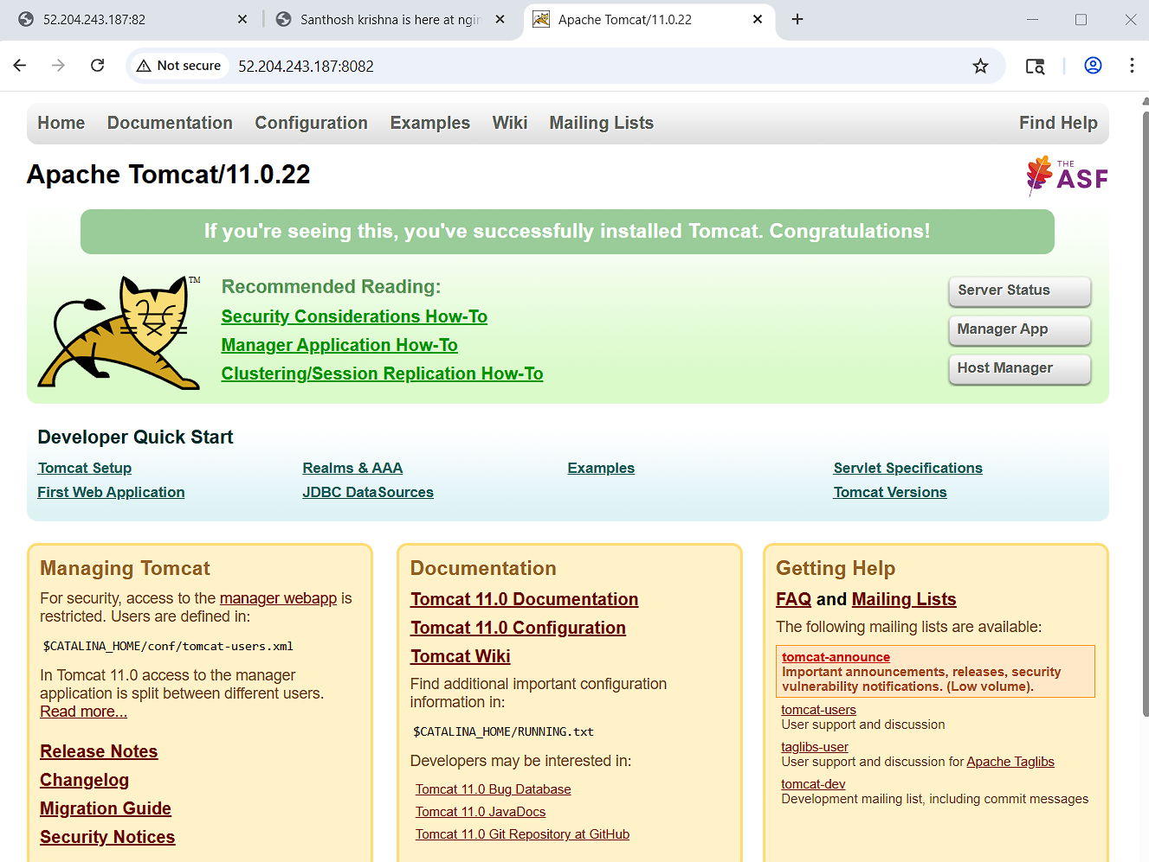

- Deploy a sample app on webapps
Cd apache tomcat directory
Cd webapps
Wget https://tomcat.apache.org/tomcat-6.0-doc/appdev/sample/sample.war
ll
Notice that sample file is extracted automatically
Go to web browser http://52.204.243.187:8082/sample
Notice that page is displayed.
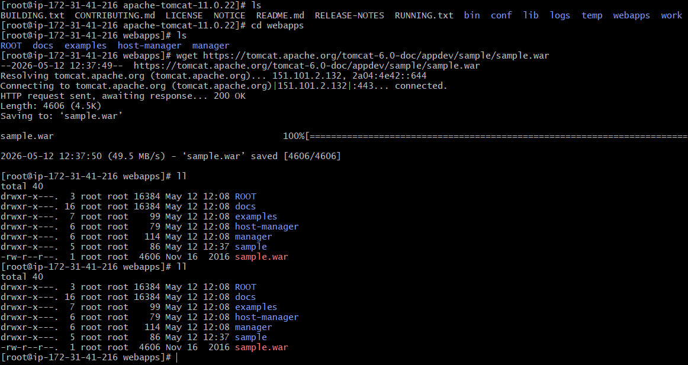
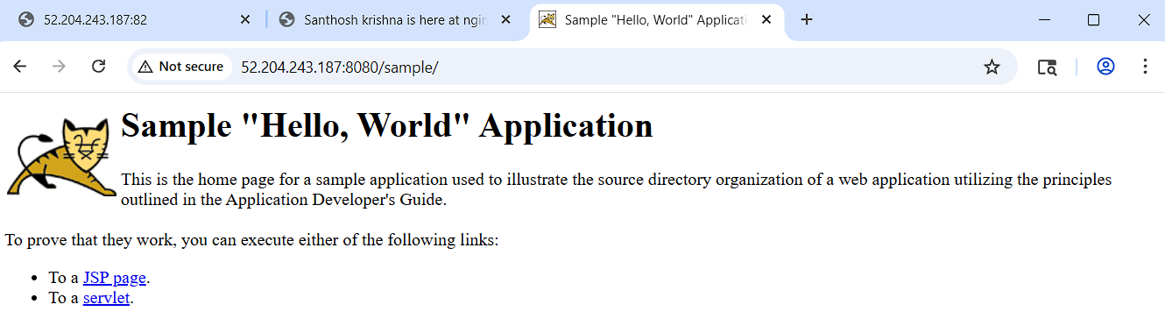

- Create a tomcat.service file for tomcat.
Install java-17
Yum install java-17
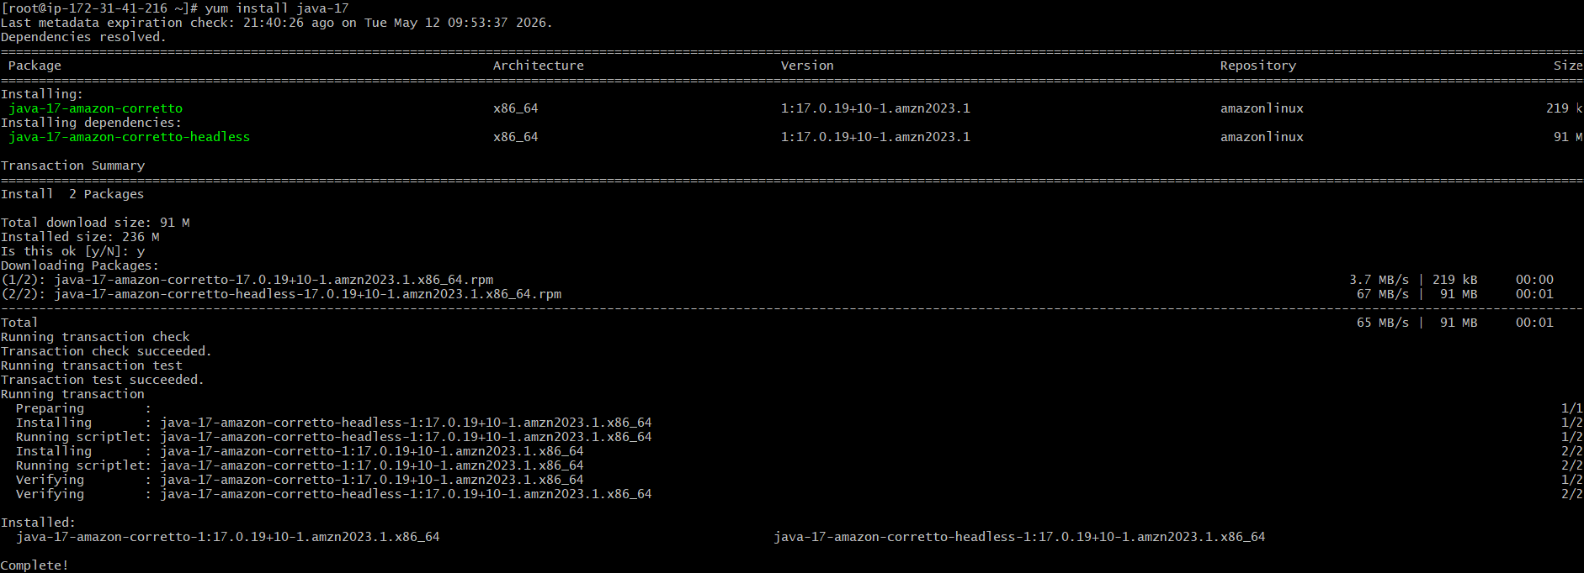
Download file from tomcat website https://dlcdn.apache.org/tomcat/tomcat-9/v9.0.118/bin/apache-tomcat-9.0.118.tar.gz
Cd /opt
Wget https://dlcdn.apache.org/tomcat/tomcat-9/v9.0.118/bin/apache-tomcat-9.0.118.tar.gz
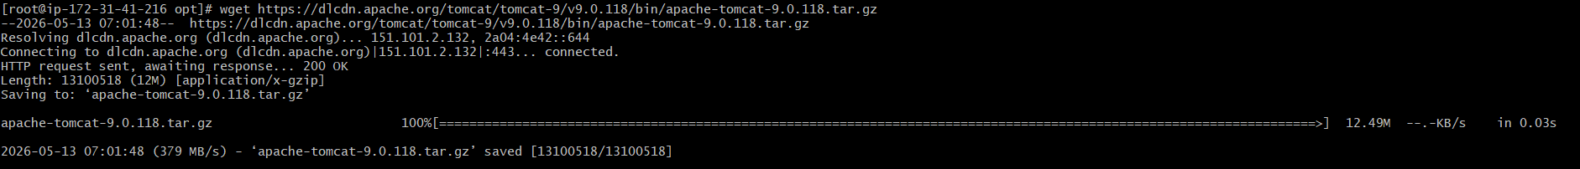
Mkdir /opt/tomcat
Cd tomcat
Extract the tomcat tar file : tar -xvzf apache-tomcat-9.0.118.tar.gz
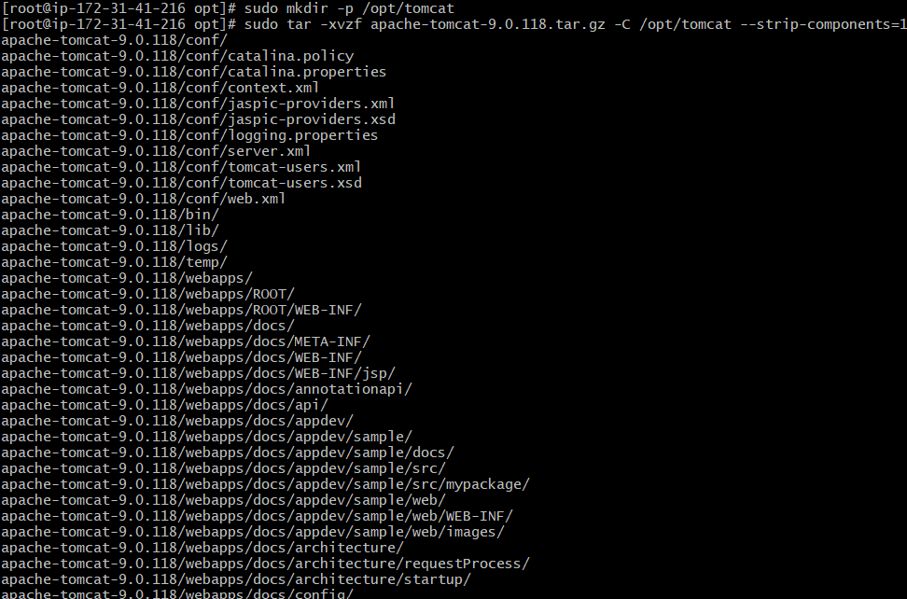
Create tomcat service file
vi /etc/systemd/system/tomcat.service
add settings to the tomcat.service file
[Unit]
Description=Apache Tomcat 9 Web Application Container
After=network.target

[Service]
Type=forking

Environment=CATALINA_HOME=/opt/tomcat
Environment=CATALINA_BASE=/opt/tomcat
Environment=CATALINA_PID=/opt/tomcat/temp/tomcat.pid
Environment=JAVA_HOME=/usr/lib/jvm/java-17-amazon-corretto
Environment='CATALINA_OPTS=-Xms512M -Xmx1024M -server -XX:+UseParallelGC'

ExecStart=/opt/tomcat/bin/startup.sh
ExecStop=/opt/tomcat/bin/shutdown.sh

User=tomcat
Group=tomcat
UMask=0007
RestartSec=10
Restart=always

[Install]
WantedBy=multi-user.target
systemctl daemon-reload
systemctl enable tomcat
systemctl start tomcat
systemctl status tomcat
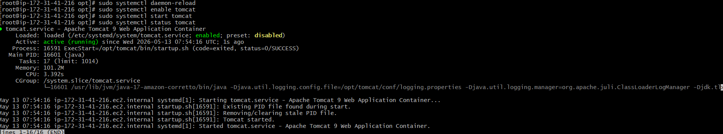

- Configure HA Proxy server
Create 3 instances in aws

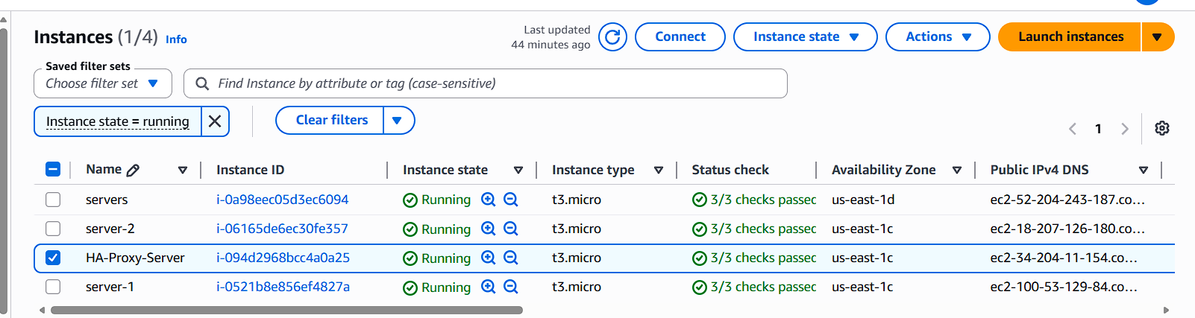

Run following command to Access the Server-1
- ssh -i your-key.pem ec2-user@Pubipaddress of Server-1 instance
- sudo -i
- yum update -y
- Yum install httpd -y
- Vi /etc/hosts
- Add HA-Proxy-Server Pubic IP Address
  - Run below command on Server-1
ping load_balancer -c 4
  - systemctl start httpd
  - systemctl status httpd
- Browse with Server-1 Public IP address:80 it will work

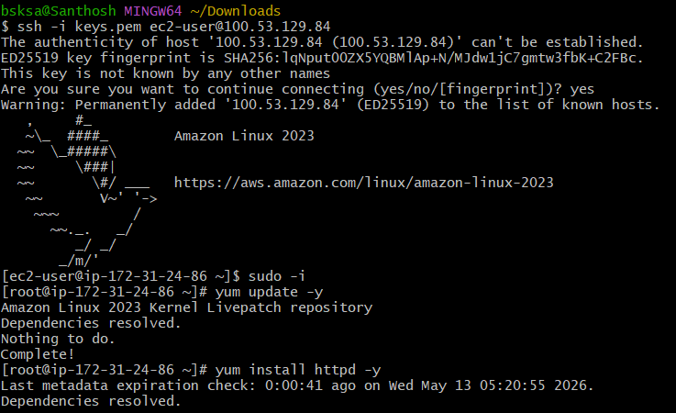

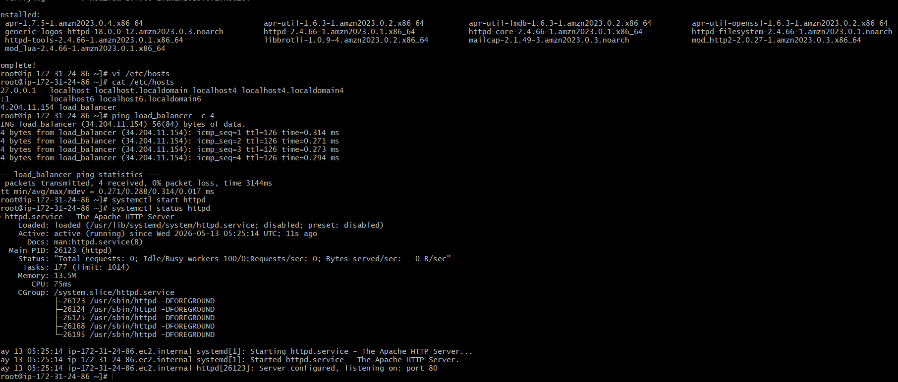

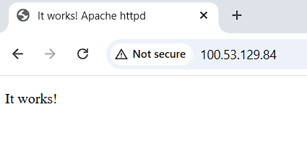
Run following command to Access the Server-2
- ssh -i your-key.pem ec2-user@Pubipaddress of Server-2 instance
- sudo -i
- yum update -y
- Yum install nginx -y
- Vi /etc/hosts
- Add HA-Proxy-Server Pubic IP Address
  - Run below command on Server-2
ping load_balancer -c 4
  - systemctl start nginx
  - systemctl status nginx
- Browse with Server-2 Public IP address:80 it will work
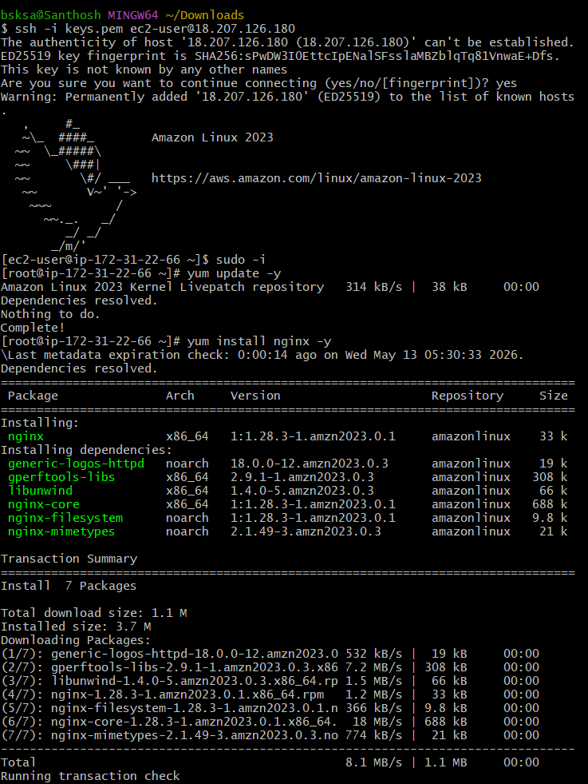

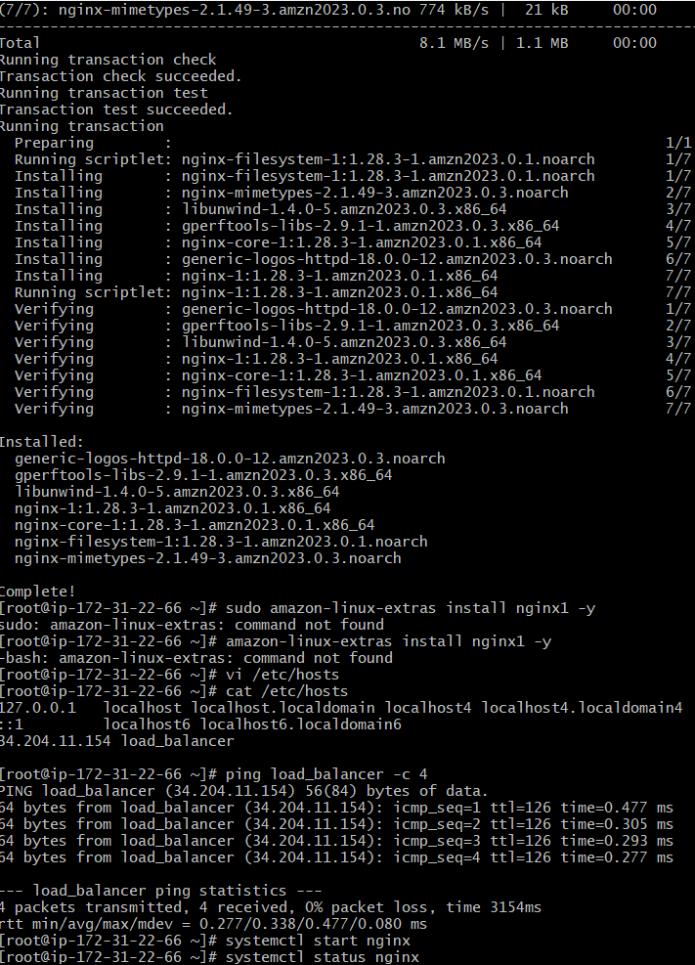

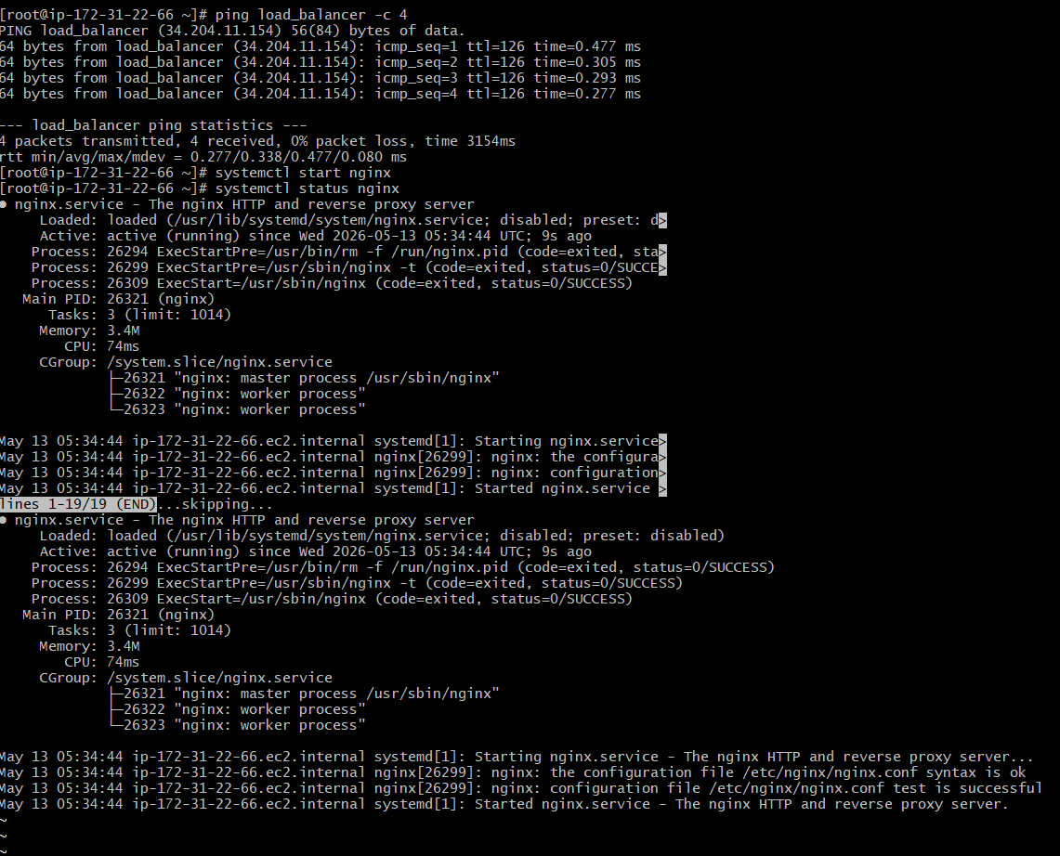

Run following command to Access HA-Proy-Server
- ssh -i your-key.pem ec2-user@Pubipaddress of HA-Proxy-Server instance
- sudo -i
- yum update -y
- Yum install haproxy -y
- Vi /etc/hosts
- Add Server-1, Server-2 Public IP’s
- vi /etc/haproxy/haproxy.cfg
- Add Server-1, Server-2 public IP’s
- systemctl enable haproxy
- systemctl start haproxy
- systemctl status haproxy
- now browse with HA-Proxy-Server PublicIP:80 it will distribute load to Server-1, Server-2

